Annual Progress Report

NSF-NER-ECS-0403669 Single-Molecule Wires and Electronic Devices Based on Dimetal Complexes Containing Metal-Metal Bonds
PI: Shouzhong Zou, Co-PIs: Hong-Cai Zhou and Jan Yarrison-Rice
Period: 2004-2005

1. Activities

The objectives of this research are to design, fabricate, and test molecular wires and single-molecule electronic devices, such as diodes, light-activated switches, and transistors, based on dimetal inorganic complexes containing metal-metal bonds. The approach is to incorporate these complexes into various two- or three-terminal nano-junctions, and measure their electron transport characteristics.
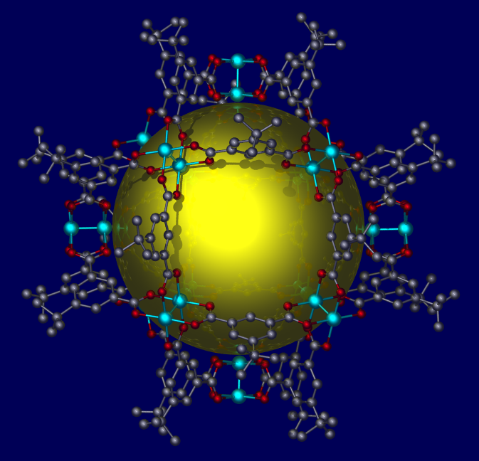
Since the inception of this NSF funding, we have started a synthetic search for molecules that can potentially be used in molecular electronics as conducting wires, diodes, and capacitors. Three papers^{[1-3]} and one presentation in an ACS national meeting^{[4]} have resulted from the synthesis work. For the measurement of conductivity of metal-metal bonds of different orders, we decided to measure dimetal units with a quadruple bond first and then compare the result with that of a single bond. If we see significant difference between the two, then we will synthesize dimetal units with double and triple bonds. So far we have made quadruply bonded dimetal units with two different bridging groups (symmetric and unsymmetrical). We have also successfully attached anchoring groups to the dimetal compounds. They are now ready for conductivity measurement. For the molecular diodes, we used the selective hard-soft binding approach that we discovered recently and synthesized eight heterobimetallic complexes. Two manuscripts have been written and are ready to be submitted. We have also tried to chemically couple quadruply bonded dimetal units into a nano-particle to study communication among the dimetal units. So far we have synthesized a cuboctahedral cluster containing 12 quadruply bonded dimolybdenum units (Figure 1).³ Right now we are trying to make it more soluble, so solution electrochemical studies can be carried out. We have also made molecular capacitors with four ditopic anchoring groups (cyanide) attached (Figure 2). These clusters also represent the first models for the all-ferrous Fe protein of nitrogenase, which nature uses as an electron carrier. We have found that in an eight-atom cluster, two (possibly three) electrons can be stored in this “molecular capacitor” reliably.
Figure 1. Molecular structure of [Mo₂₄(BBDC)₂₄](py)₁₂. Pyridine groups and all hydrogen atoms are omitted for clarity. The golden sphere represents solvent-accessible space inside the cage (Y. Ke, D. J. Collins, H.-C. Zhou, Inorg. Chem. 2005, 44, 4154.
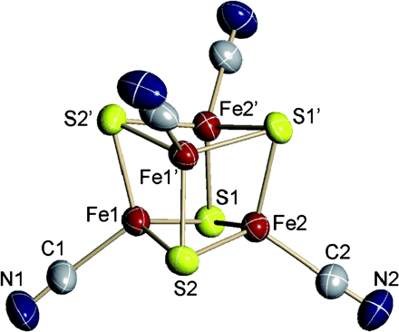
We have developed a method that allows the simultaneous acquisition of both Raman spectra and current-voltage (I-V) curves of molecules sandwiched between two metal electrodes. In this approach, the bottom electrode was carefully prepared on a glass slide by thermal vapor deposition to yield the surface-enhanced Raman (SER) effect. After a monolayer of molecules was formed on this substrate, a top electrode was deposited again by thermal vapor deposition using a shadow mask containing arrays of circular holes of 0.5 mm radius (Figure 3A). Each circular pad together with the bottom electrode forms a device. The SER spectra of molecules sandwiched in these molecular electronic junctions can be obtained simultaneously with the I-V measurements. To demonstrate the approach, we used 1, 4 – phenylene diisocyanide (PDI) because the molecule has been shown to form a compact monolayer on Au with one of the NC groups attached to the surface and the other pendant which can therefore bind to the top electrode. Moreover, the molecule shows interesting electron transport characteristics at low temperatures. Two types of junction were tested. The Au/PDI/Au yields a symmetric non-linear I-V curve which resembles that reported in the literature (Figure 3B). The asymmetric Au/PDI/Al/Au junction shows a weak rectification effect that can be attributed to the double asymmetric structure of the junction. The simultaneously recorded Raman spectra demonstrate that the molecular structure is intact. These results are reported in a manuscript submitted to Analytical Chemistry⁵ and presented at the 2005 Pittsburgh Conference as well as the American Physical Society National meeting.^{6,7}
Figure 2. Structure of [Fe₄S₄(CN)₄]^{4–} showing 50% probability ellipsoids (T. A. Scott, C. P. Berlinguette, R. H. Holm, H.-C. Zhou, Proceedings of the National Academy of Sciences of the United States of America 2005, 102, 9741.
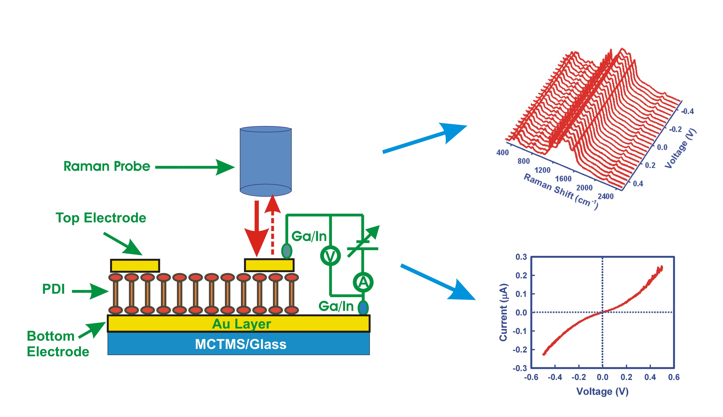
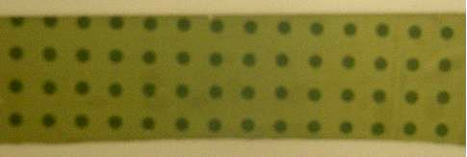
B
A
Figure 3. (A). A photograph of the top view of an array of 1 mm gold circular pads. (B). A schematic diagram of the experimental setup for coupled SERS and I-V measurements on a Au/PDI/Au molecular electronic junction. The SER spectra were taken while the I-V curve was recorded.

Nanogap electrodes for measuring electron transport properties of a single molecule have been fabricated via electron-beam lithography and electrodeposition as well as electromigration on silicon substrates. Pairs of single Cr:Au electrodes were first fabricated using electron-beam lithography on silicon substrates with a 200 nm layer of thermally oxidized silicon. Each electrode pair is begins at 1 μm width and then tapors to 500 nm wide and ~200 μm long, terminating on a 500 μm x 500 μm contact pad. After the PMMA resist was developed, a ~30 nm layer of Chromium was thermally evaporated onto the patterned substrate to enhance the adhesion of the ~220 nm layer of gold. Each silicon chip containing a total of 10 electrode pairs is epoxied with a non-conducting epoxy into a package for external electrode connections. After numerous trials, we determined that a 700 nm gap in each junction kept the electrodes smoother and could still be closed via electrodeposition and then re-opened using electromigration (see Fig. 4).
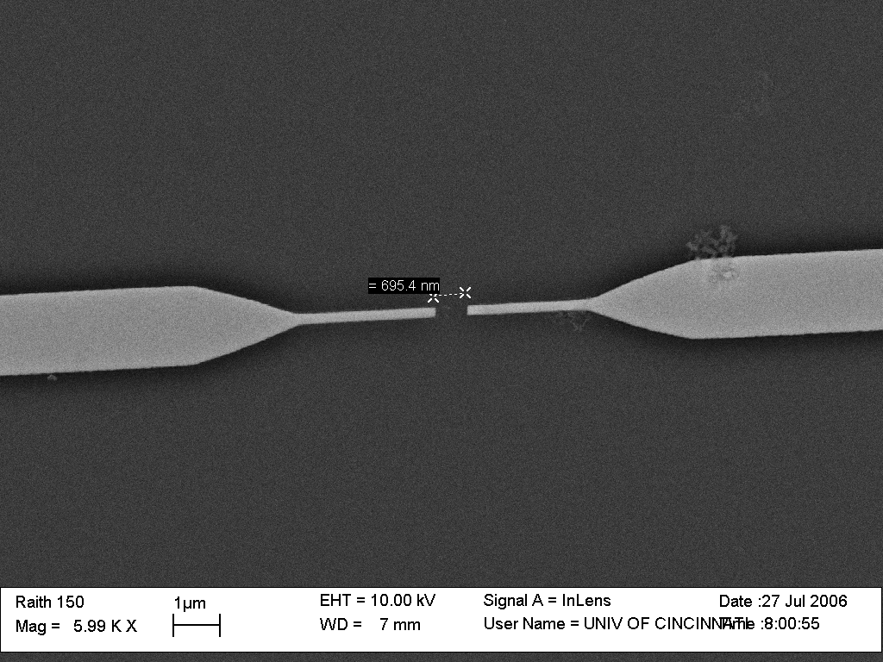

Figure 4: The new design electrode before electrodeposition. The initial gap size is 700nm

Both the electrodepostion and the electromigration are monitored with a circuit measuring the step-wise changes in current as a function of time for a particular applied voltage.
A new method for confining the electrolyte using a modified tip of a pipette, provided well-controlled electrodeposition to close the gaps. When the electrolyte when poured from top into the pipette’s other end made contact with only the local region around a single electrode pair.

The fabricated nanogap electrode pairs were characterized in the following two ways 1) by SEM micrographs of the nanogap, and 2) the I-V curve of the nanogap. The electrode pair in Fig. 5 shows the successful electrodeposition and resulting <10 nm gap as seen in an SEM.

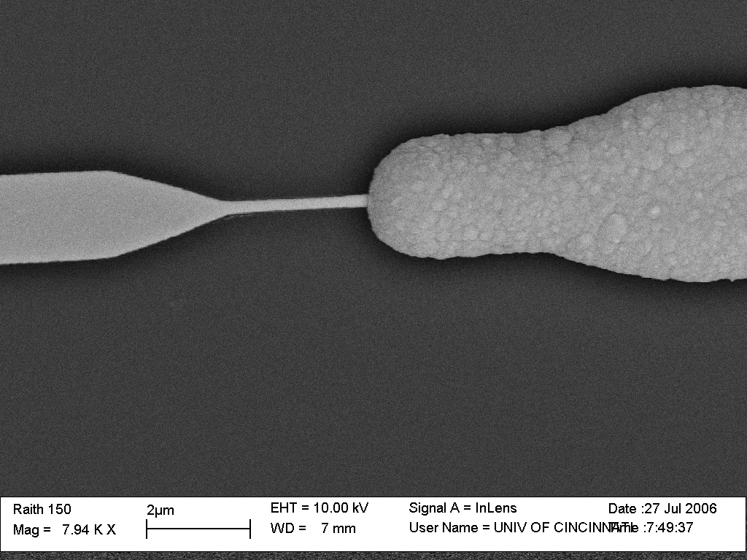

a)

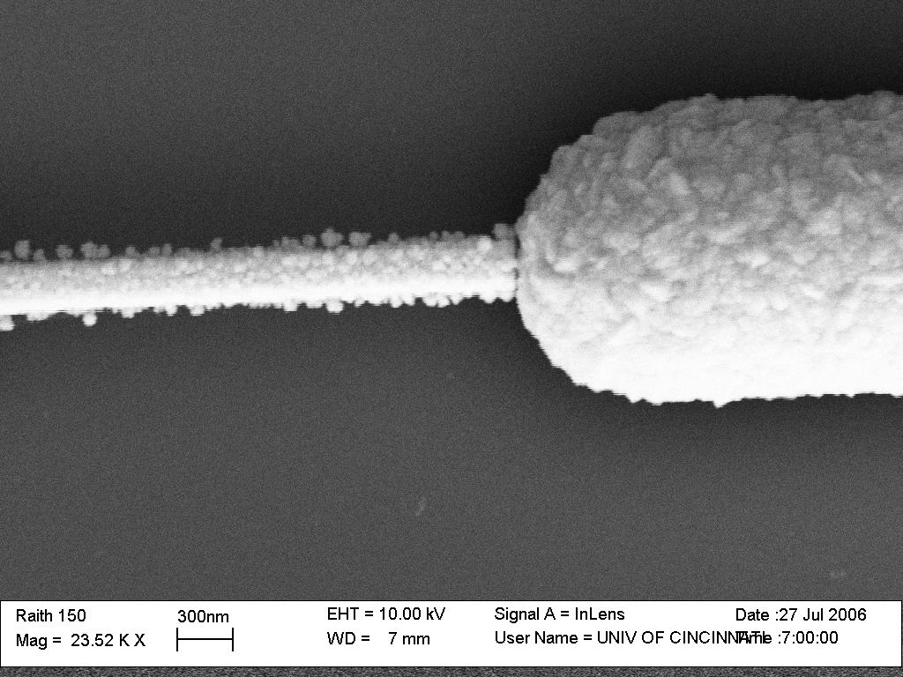
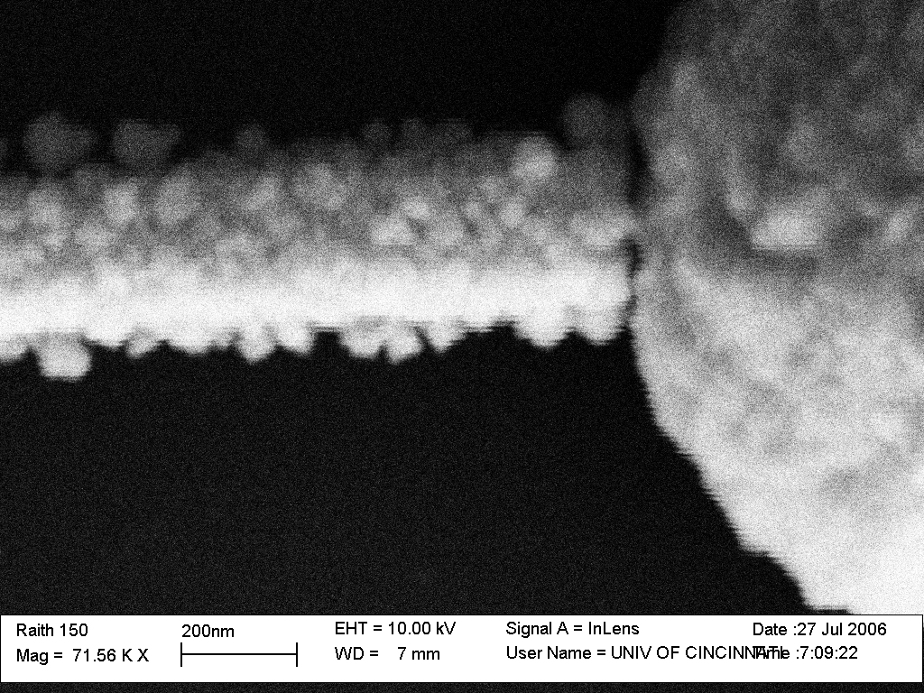

b)

b) c)

Figure 5: (a) A typical electrode pair after electrodeposition using the new pipette method (scale 2 mm), (b & c) Closeup SEM scans of the nanogap at 300 nm and 200 nm scales respectively.

The I-V curve of the electrode pair shows that portions of the nanogap are actually completely closed with the current in the order of 10⁻⁴ Amps. (Fig. 6) This current corresponds to to a resistance of 170 Ohms. We then performed electromigration on this electrode pair. After connecting the two terminals of the galvanostat to the ends of the electrode pair, a constant current is passed through the connected nanogap. This current is ramped slowly until the point electromigration begins. The current is then held constant which leads to formation of nanogap due to migration of Au atoms in the opposite directions

Figure 6. I-V curve of Pair 1 after electrodeposition. The resistance was calculated as 170 Ohms. The curve is linear showing an Ohmic behavior.

The tunneling current through a nanogap of 1nm size according to literature is estimated to be in nanoAmpere range. The I-V graphs after electrodeposition and subsequent electromigration to break the junction are shown in Fig 7.

Figure 7:. I-V curve of pair 1 after washing/cleaning. The resistance was calculated as 10 MOhms. The curve is almost linear and the current is in 0.1 nA indicating the existence of larger nanogap. The ramp rate at which potential was increased is 10 mV/S between a range of –0.050 V to + 0.050 V

There is a slight instrumental offsetin Fig. 7, however the range of the current is consistent with a nanogap in the range of 0.5 to 1.5 nm as calculated in the following method. The tunneling model from STM theory can be applied to our system of two closely-spaced Au electrodes. The equation which describes the current through a nanogap junction is given below.
I = ρ_{s} V exp(-ks) …Eq. (1)
Where
I = the tunneling current
ρ_{s} = density of state of nanogap interface
V = applied bias potential
k = constant
s = nanogap size

Using the I-V curve of the nanogap, we can estimate s. Using a literature value for k of 0.92 ± 0.16 Å⁻¹. We also have adopted a value for ρ_{s} determined by another group, which had the same electrode configuration and design, of 5 x 10 ⁻⁵ S. Therefore we determine that the nanogap fabricated is in the range of 5.4 – 12 Ǻ. This is in good agreement with our I-V data.
Results of this work were presented in international meetings and are published in IEEE proceedings.

Pedagogical Activities
For education activities, a graduate level course on nanotechnology and molecular electronics was co-taught by the PI and Co-PIs. Students from Physics and Chemistry departments took the class. The course covers: fabrication of nano-structure, techniques for characterizing nanomaterials, properties of nanoparticles, carbon nanotube, molecular electronics, bionanomaterials and application of nanomaterials. In addition to the current literature, several monographs were used in this course, such as those edited by Klabunde⁹ and by Schmid.¹⁰ Cooperative learning and problem-based learning approaches are incorporated in the course. Assignments include oral presentations on the above topics and writing critical reviews on selective papers from journals. Student-led discussions of several selective papers were conducted as well. A blackboard site has been created for the project participants to communicate ideas and share literature resources. Several undergraduate students were trained in the research laboratory and have participated in various aspects of the project.

Papers & Presentations Resulting from NSF Funded Grant – 2005-6

[1] “Conductivity measurements of paddlewheel dimetal complexes with metal-metal multiple bonds,” S. Rajagopal, N. Smith, J.M. Yarrison-Rice, C. Urig, T.A. Scott, H. Zhou, and S. Zou, 6th IEEE Nanotechnology Proceedings, ISBN 1-4244-0078-3 (4 page paper) 2006 Accepted.

Publications and Presentations – 2004-5

[1] T. A. Scott, H.-C. Zhou, The first all-cyanide Fe₄S₄ cluster: [Fe₄S₄(CN)₄]³⁻, Angew. Chem., Int. Ed. Engl. 2004, 43, 5628-5631.
[2] T. A. Scott, C. P. Berlinguette, R. H. Holm, H.-C. Zhou, Initial synthesis and structure of an all-ferrous analogue of the fully reduced [Fe₄S₄]⁰ cluster of the nitrogenase iron protein, Proceedings of the National Academy of Sciences of the United States of America 2005, 102, 9741-9744.
[3] Y. Ke, D. J. Collins, H.-C. Zhou, Synthesis and Structure of Cuboctahedral and Anticuboctahedral Cages Containing 12 Quadruply Bonded Dimolybdenum Units, Inorg. Chem. 2005, 44, 4154-4156.
[4] T. A. Scott, C. P. Berlinguette, H.-C. Zhou, R. H. Holm, First active-site analogue for the all-ferrous iron protein of nitrogenase, 230th ACS National Meeting, Washington, DC, Aug. 28-Sept. 1, 2005.
[5] A. Jaiswal, K. G. Tavakoli, S. Zou, Coupled Surface-enhanced Raman spectroscopy and electrical conductivity measurements of 1, 4-phenylene diisocyanide in molecular electronic junctions, Anal. Chem., submitted.
[6] A. Jaiswal, K. G. Tavakoli, S. Zou, Coupled Raman spectroscopic and electrical measurement of diisocyanide monolayers sandwiched between two gold electrodes, Pittcon 2005, Orlando, FL, Feb. 26 - Mar. 4, 2005.
[7] N. Smith, A. Jaiswal, J.M. Yarrison-Rice, S. Zou, Fabrication of single digit nano-gap electrodes by e-beam lithography for coupled Raman spectroscopy and electrical conductivity of single molecules: early measurements between larger electrodes and fabrication results, Am. Phys. Soc. Mtg., Los Angeles, CA, March 2005
[8] N. Smith, J.M. Yarrison-Rice, A. Jaiswal, T. Scott, H. Zhou, S. Zou, Electrical conductivity measurements of single molecules, Ohio Nanotechnology Summit, Dayton, OH, March 2-3, 2005.

Texts Used in Nanotechnology & Molecular Electronics Course

[9] Schmid, G., Nanoparticles: From Theory to Application. Wiley-VCH: Weinheim, 2004.
[10] Klabunde, K. J., Nanoscale Materials in Chemistry. Wiley: New York, 2001.

