Phy101: Practice Exam #2

1.) Choose the best definition of thermal energy listed below.

a. The energetic jostling, in a purely random fashion, of atoms and molecules comprising a body.
b. The flow of jiggling atoms from one body to another.
c. A quantity that relates to the average kinetic energy of the molecules comprising a body.
d. The point when atoms and molecules have lost all their kinetic energy.
e. The amount of heat required to change the temperature of a body.

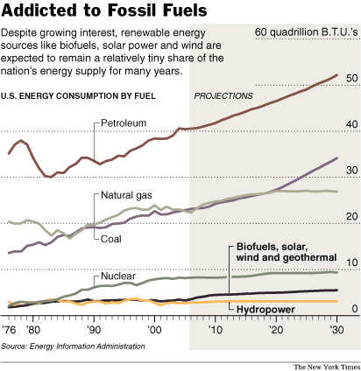

2.) Using the graph above, choose the correct statement.
a. As of 2006, both coal and natural gas are being consumed in the same quantity.
b. As of 2030, hydropower will have increased by a factor of two over 2006 usage.
c. The projections for petroleum use have it increasing to about 40 quadrillion BTUs in 2030.
d. Alternative fuels will be a high percentage of our future fuel use as projected by this graph.
e. In 2006, petroleum was utilized more than twice as much as coal.

3.) While the last 100 years have only experienced an increase in temperature of about 0.5oC or 0.7oF, the modest global temperature _________ was responsible for the last ice age (10,000 years ago).
a. increase of 3oF
b. drop of 9oF
c. increase of 10oF
d. drop of 30oF
e. drop of 50oF

4.) A CSI agent finds droplets of melted silver at a crime scene. If she wanted to decide if the droplets were created by silver dropping from a high water tower at the scene, how high would the tower have to be for this to be possible? We assume that all the energy from the fall can go into heating the silver to its melting point. Temperature at scene is 22ºC and melting temperature of silver is 960.8ºC.
[C = 234 J/kgºC]

a. 22,942 m
b. 11, 208 m
c. 22.4 m
d. 22,416 m
e. 11.2 m

5.) The greenhouse effect is predominantly caused by large concentrations of _________ in the atmosphere caused by emissions from ________________ industries, and power plants, and excessive deforestation of the planet.

a. CO2, cars b. O2, cows
c. S, furnaces d. Fe, vehicles
e. H, electric heaters

6.) The amount of heat required to raise 4 kg of gasoline from 24oC to 59oC is _________. The specific heat capacity of gasoline is c = 0.5 Cal /kgºC.

a. 17.5 Cal.
b. 35 Cal.
c. 70 Cal.
d. 140 Cal.
e. 105 Cal.

7.) Suggestions made in class to lower the concentration of CO2 in the atmosphere and slow down the greenhouse effect include all but one of the following. Choose the INCORRECT suggestion.

a. Develop alternate energy sources.
b. Use cars less often and find methods of cleaning the exhaust.
c. Stop cutting the rainforests and other forests.
d. Use alternate sources for making paper such as hemp.
e. Change the wavelength of the radiation of the earth making it longer.

8.) If your instructor were to place a 0.5 m bar of aluminum in a flame and then after a period of time the length was measured to be 0.5005 m, what increase in temperature did the bar undergo while being heated? [α(aluminum) = 24x10-6(oC)-1]
a. 4 oC
b. 21.6 oC
c. 41.7 oC
d. 834 oC
e. 41708 oC

9.) In the graph at left, we see the 2005 gas imports from Russian supplies by various countries. The percents from Russia are on top and percent of total energy derived from gas along the side.Which of the following statements is FALSE?

a. Hungary has the largest percentage of its energy supplied from gas.
b. Although Greece has the smallest percent of its total energy from gas, it imports largely from Russia.
c. France is the least energy dependent on Russian supplies.
d. Poland, France, and Bulgaria use about the same amount of gas to produce energy in their countries.
e. Greece is the least energy dependent on Russian supplies.

10.) If a new light bulb were developed that was able to produce 150W of visible radiation for an input of only 200W of electrical energy, what would its efficiency be?
a. 75%
b. 66%
c. 55%
d. 95%
e. 25%

11.) Choose which of the statements below on implications of global warming is INCORRECT.

a. Habitats will change as the climate changes and thus many animals and plants will be in danger of becoming extinct.
b. With changes in weather, various existing businesses like insurance agencies, and tourism sites (both coastal and mountainous) will flourish.
c. As habitats for various insects change (for instance the mosquito), diseases in animals and people could become a global epidemic.
d. Coastal communities will need to make plans which include shoreline buildup, new housing regulations, and possibly ways to desalinate water.
e. The US will have to consider its policies with respect to taxes, storm relief (natural disaster relief), and relief worker training and numbers needed.

