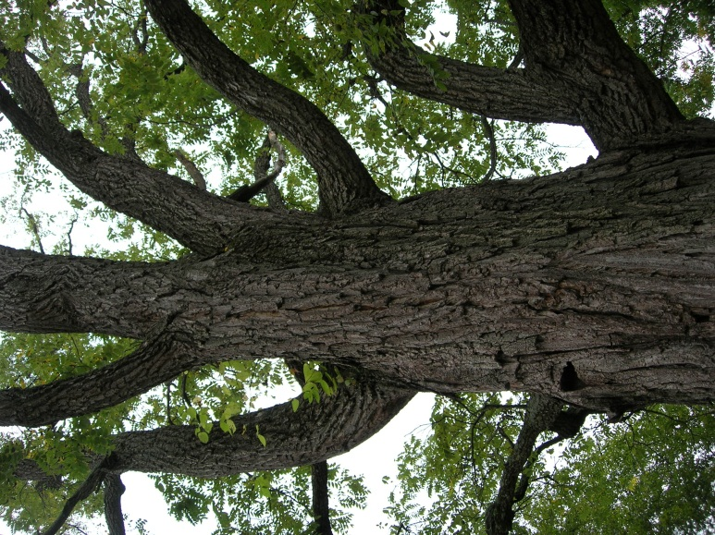
The Black Walnut tree is native to the Central and Eastern United States. These trees are generally large in size, averaging 70-150 feet in height. The trunks have been known to be between 2-4 feet in diameter. The fruit borne from this tree, the walnut, is consumed by both animals and humans. It can be eaten both naturally or it can be procured and used in recipes. Walnut lumber is popular for making furniture items such as tables or cabinets as well.

By: Karin Koenig

Juglans nigra
Black Walnut

Black Walnut: Short History

Sources:
The Illustrated Book of Trees
By: William Carey Grimm

www.na.fs.fed.us/pubs/silvics_manual/
volume_2/juglans/nigra.htm

ostermiller.org/tree/blackwalnut.html

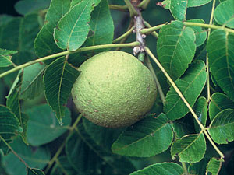
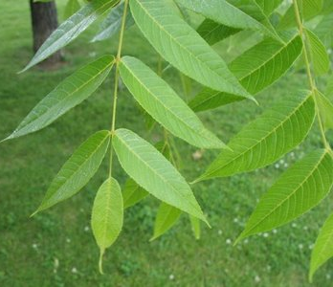

Insects and Diseases
Drilling insects, such as the ambrosia beetle, weaken the tree, making it susceptible to fungi like Fusarium. This fungus causes parts of the plant to die and regrow starting at the tree base. Most recently discovered is a serious leaf-spotting disease which is thought to be caused by a fungus known as Mycosphaerella junglandis.

The Walnut
The fruit of the Black Walnut Tree is known as the walnut, hence the name of the tree. While this fruit has a pungent smell, the kernel inside the outer husk has many uses. Squirrels and other such animals eat the nut in its natural state. Walnuts are safe for humans to eat as well. They have been used in foods such as ice cream and salad for many years, but qurprisingly, consummation is not all they are used for. One might be interested to find out that ground up walnut shells have been used as jet engine cleaners and as part of a non-slip formula in car tires.

Physical Attributes of Juglans nigra
As stated before, the first thing many people notice about the Black Walnut tree is its massive size. Growing between 70-150 feet tall, its bark is deep brown and runs in thick ridges along the entirety of the trunk. The leaves are arranged alternately along the branches and are pinnately compound, each leaf containing about 13-27 individual leaflets. These leaflets are lance-shaped with oblique bottoms, and range between 2 ½“– 3“ in length.

