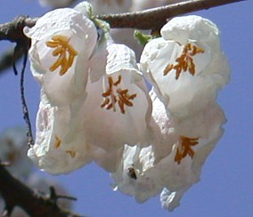
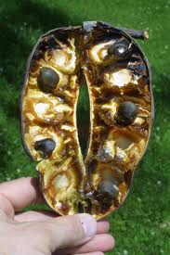
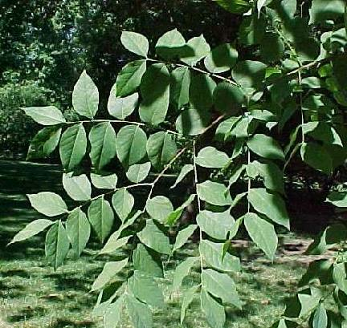
alAndrew Phelan
Kentucky Coffeetree

Gymnocladus dioicus
-AKA the “Dead tree” or “Stump tree”

-Considered a rare tree species due to over harvesting
Characters:
-Dark green & glabrous above, paler under
-Leaves are 1’-3’ long, around 2’ wide, fall color usually yellow
-Alternate, Bipinnately, & sometimes Tripinnately compound.
-Leaflets 2’’-2 1/2’’ long 1’’-1 1/2’’ wide.
- The leaflets are ovate , pointed at the apex with the base being rounded. The leaflets are also broadest slightly below the middle.
Poisonous
The leaves, seeds, & pulp are poisonous and toxic to humans, pets, & livestock. Symptoms: -gastrointestinal irritation
-diarrhea & vommiting
Fruit/ Legume
Thick pods found that contain large seeds or beans. These fruit are found only on female trees and they usually stay on the tree throughout winter.
Why Coffeetree? Early settlers used the beans from the tree to roast an alternative to coffee. Native Americans also roasted the beans for food.
Pests/Problems
-It is a pest free tree.
-Used generally for ornamental purposes The legumes fall on ground,can be messy,used in urban areas today

-The Flowers greenish white
-They appear in May & June
-The Flower has 5 petals, and are obovate
-Male and female flowers are borne on separate trees
-The flowers bloom after the leaves appear
-Legume is 4’-10’ long & 1’-2’ thick , usually brown or reddish-brown
-Legume contains 4-8 usually green, brown , or black seeds that are separated by brown pulp.
-Tree is dormant for 6 months during the year
-Winter buds are small & red , terminal buds are absent,nearly buried within the bark
-Stout twigs light brown - green with some white patches, they have heart shaped leaf scar , salmon to brown pith.
Wood:
heavy density, coarse & straight grain, also soft
no odor or taste, sometimes confused with Honey and Hickory woods
sometimes used in cabinetwork, fence posts, and in construction.
-Usually a medium size tree , height ranges from 40’-75’
-Trunk diameter is usually 1’-2’, usually divides above ground into 3-4 limbs which then form an narrow obovate crown.
-Stout and clumsy looking branches
-Grows in the bottomlands in deep, moist, fertile soils, open woods,Ranges from central New York/ Ontario to Minnesota, & south to Tennessee & Oklahoma. Grows mainly in the western half of Ohio.
-Thick, dark bark , gray or grayish brown, usually marked with deep, irregular furrows and plates that curl at the sides.
Distinctions: -contorted branches, very large twice compound alternate leaves, winter twigs that seem to lack buds, dormant for half the year
What is the basis for the name Kentucky Coffetree?
the leaves and bark smell like coffee
there is a coffee tasting pulp in the legume
the beans have been used as an alternative to coffee by settlers in the past
Instead of needing water to grow this tree needs coffee
all of the above

