Little Leaf Linden
General Description:
Medium sized tree native to Europe, with a noticeably dense pyramidal to rounded crown. It is a desirable specimen tree for landscaping. The flowers are highly fragrant and attractive to bees. The largest tree in North Dakota is 35 feet tall with a canopy spread of 32 feet.
Scientific Name: Tilia Cordata
Size: 60 – 70 feet high
Spread: 30 – 40 feet
Range: Originated in Europe and western Asia also found in North America
Uses: Ornamental and shade tree, in Europe the flowers are used as an herbal remedy and tea, the wood is used for furniture and wood carving.

By: Thomas Merriweather
BOT 155
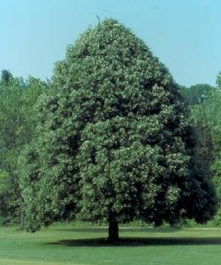
Details
Leaves: Simple, cordate or heart-shaped, oblique base.
Flowers: greenish yellow cymes are edible
Fruit: Fruit is a small thin shell nutlet
Bark: Brown to gray, with long ridges
Pest: Aphids, Japanese beetles, and sooty mold
Multiple Choice Questions:
What common North American tree is related to the Littleleaf Linden?
- Honey Locust
- Eastern Redbud
- Carolina Red Maple
- American Basswood

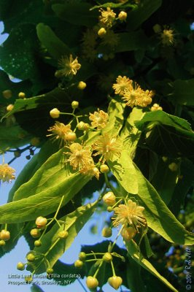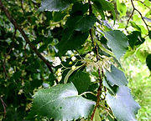
References:
Littleleaf Linden
http://www.ag.ndsu.edu/trees/handbook/th-3-125.pdf
Tilia Cordata, Wikipedia, http://en.wikipedia.org/wiki/Tilia_cordata
Grimm, William; and Kartesz, John. The Illustrated Book of Tree The Comprehensive Guide to More to More Than 250 Trees of Eastern North America. New York: Stackpole Books, 2002.
Littleleaf Linden, http://www.treehelp.com/trees/linden/trees-species-linden-types-littleleaf.asp

Forestry Images: Forest Health, Natural Resources, Fire, Trees http://www.forestryimages.org/browse/detail.cfm?imgnum=5034071





