Releve' Analysis
The releve' method is a straightforward method of describing a community based on simply listing the plants. The sophistication of the technique can range from a simple plant list to a concise, but highly descriptive fact sheet.
Each releve' report should include the date, location, position, plant community , size of the releve', stratification of the community, soil characteristics, comments on level of disturbance or other facts of interest, and a list of the plants present and there abundance.
Plant Communities we may encounter in Field Botany: Eastern Deciduous Forest Juniper Woodland Shrubland Herbaceous agricultural weed community
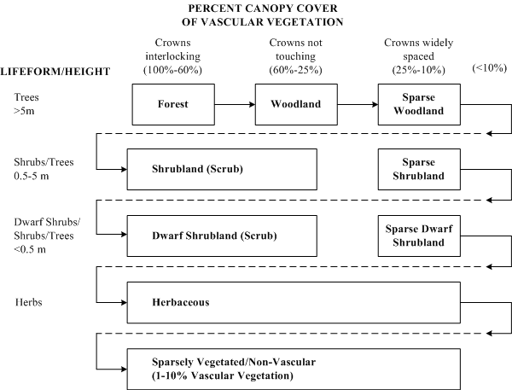
Source: http://www.dnr.state.mn.us/eco/mcbs/vegetation_sampling.html

The following is a guide to the minimum area (quadrat size) that should be sampled in your releve':
Community | Minimum area to survey
Forests and Woodlands (tree stratum only) | 200 – 500 m²
Forests and Woodlands (undergrowth only) | 50 – 200 m²
Dry grassland | 50 – 100 m²
Dwarf shrub heath | 10 – 25 m²
Hay meadow | 10 – 25 m²
Fertilized pasture | 5 – 10 m²
Agricultural weed communities | 25 – 100 m²
Moss communities | 1 – 4 m²
Lichen communities | 0.1 – 1 m²

We will use the Braun-Blanquet method to describe the structure of our community. This method involves identifying all the species represented it a quadrat, and then assigning a code number to that species based on its relative abundance in the quadrat.
Braun-Blanquet Code Number | % Cover of Species
0 | Species not present
1 | Species < 5% of total
2 | Species = 5 – 10% of total
3 | Species = 10 – 25% of total
4 | Species = 25 – 50% of total
5 | Species = 50 – 90% of total
6 | Species > 90% of total

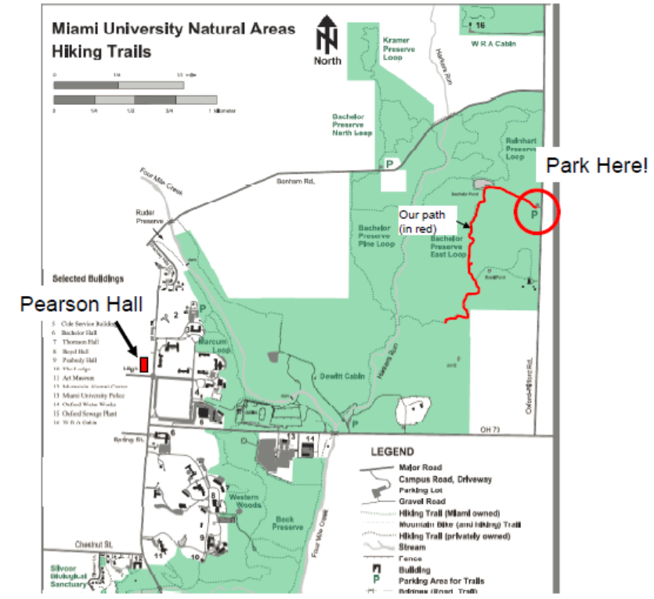

You will be conducting Revele' Analyses in regions 7, 8, and 10 within the Bachelor Reserve. The beginning and end regions of each of these areas are marked with pink surveying tape along the hiking trail.
On our first visit, the following objectives should be attained:
1. Organize your team and discuss how you will conduct your Revele' data collection.
2. Become familiar with each of the three sites (7,8,10) where you will be conducting your Revele' Analyses in terms of:
A. All the species in all the different layers in each site. Key out any unknown species that you might encounter.
B. Potential Revele' sample areas for each of the three sites. These areas should be selected away from the trail (to avoid edge effects) and be positioned to best represent the "average" vegetation characteristics of each of the three sites.

