Releve' Analysis
The releve' method is a straightforward method of describing a community based on simply listing the plants. The sophistication of the technique can range from a simple plant list to a concise, but highly descriptive fact sheet.
Each releve' report should include the date, location, position, plant community , size of the releve', stratification of the community, soil characteristics, comments on level of disturbance or other facts of interest, and a list of the plants present and there abundance.
Plant Communities we may encounter in Field Botany: Eastern Deciduous Forest Juniper Woodland Shrubland Herbaceous agricultural weed community
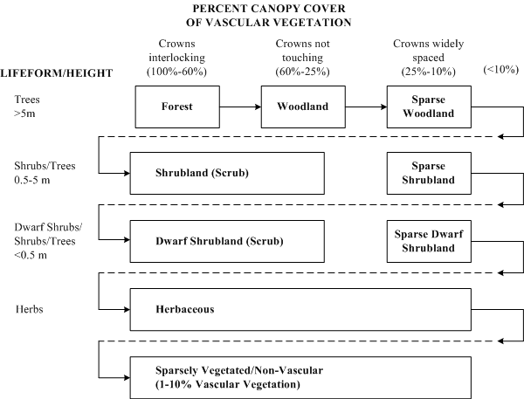
Source: http://biology.usgs.gov/npsveg/classification/sect5.html

The following is a guide to the minimum area (quadrat size) that should be sampled in your releve':
Community | Minimum area to survey
Forests and Woodlands (tree stratum only) | 200 – 500 m²
Forests and Woodlands (undergrowth only) | 50 – 200 m²
Dry grassland | 50 – 100 m²
Dwarf shrub heath | 10 – 25 m²
Hay meadow | 10 – 25 m²
Fertilized pasture | 5 – 10 m²
Agricultural weed communities | 25 – 100 m²
Moss communities | 1 – 4 m²
Lichen communities | 0.1 – 1 m²

We will use the Braun-Blanquet method to describe the structure of our community. This method involves identifying all the species represented it a quadrat, and then assigning a code number to that species based on its relative abundance in the quadrat.
Braun-Blanquet Code Number | % Cover of Species
0 | Species not present
1 | Species < 5% of total
2 | Species = 5 – 10% of total
3 | Species = 10 – 25% of total
4 | Species = 25 – 50% of total
5 | Species = 50 – 90% of total
6 | Species > 90% of total

