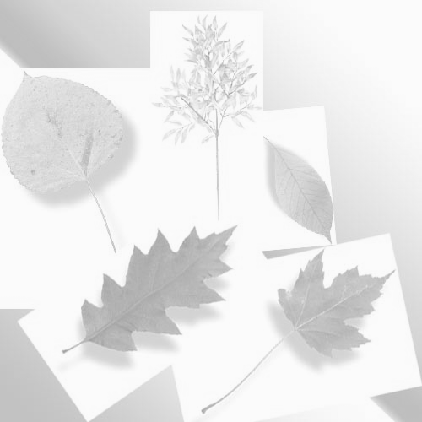

Plant Collection Project
Botany 155

Prepare a collection of 50 plant specimens.
1. Check out a plant press from your instructor. Plant presses must be returned at the end of the semester. If you fail to return your press 50 points will be deducted from your course total. If you would like to keep your press you may purchase it for $5.00.
2. Collect fresh plant material and include leaves, stems, flowers and fruit material (when possible).
3. Identify the collected plant and record where and when it was collected.
4. Press the plant material and allow it to dry.
5. Mount dried specimens with glue on index cards or in a sketchbook.
6. Label each specimen with the following information:
A. Your name, the date and place collected. B. Common name, scientific name, plant family name
Due dates for your collection are listed in the syllabus. You grade will be based on creativity, completeness, neatness and accuracy.

