Books
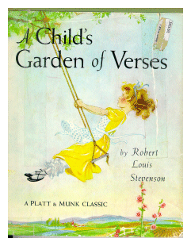
A Child’s Garden of Verses:
by Robert Louis Stevenson
In this book, the poem “The Swing”
Allows the student to help visualize the back and forth motion of a
pendulum. ISBN: 0027883655

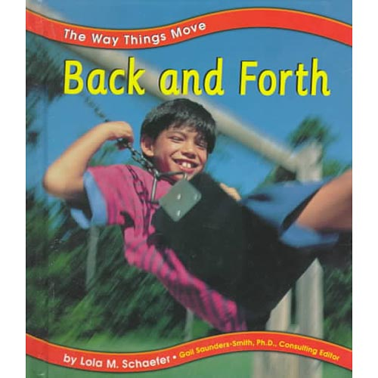
Back and Forth by Lola M. Schaefer
Simple text and photographs provide examples of back and forth movement, including the pendulum on a clock, a child in a rocking chair, and a tree in the wind.
ISBN: 073680398X

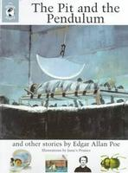
The Pit and the Pendulum and other Stories by Edgar Allan Poe
Presents seven stories from the mid-nineteenth century which include illustrated notes through-out the text explaining the historical background of each story.
ISBN: 0670887064 (Hardback) ISBN: 0670887250 (paperback)

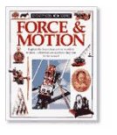
Force and Motion
by Peter Lafferty
Explores the principles of force and motion, describing how they have been applied from ancient to modern times. ISBN: 1879431858


The Boy Who Stopped Time by Anthony Taber.
Julian does not want to go to bed at 7:30, so while his mother is singing his little sister to sleep, he stops the pendulum in the grandfather
clock. A hush falls over the house. Everyone is silent. Everything is still. Time has stopped. Taber's beautiful pencil drawings capture the eerie quiet of Julian's world--until, at last, Julian sets the clock pendulum swinging again. ISBN: 0689504608


Galileo Galilei: Inventor, Astronomer,
and Rebel by Michael White
Galileo Galilei was one of the world's great-
est scientific pioneers. His work ranged
through mechanics and motion, to sound,
speech and light, astronomy, and the system
of the universe. Despite his outstanding
contributions to science, he was labeled a
heretic by the Catholic Church and was imprisoned for life. ISBN: 1-567-11325-7

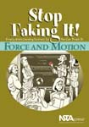
Stop Faking It! Force and Motion
by William C. Robertson
This series is intended for science
teachers, and parents who want to help with homework. The book combines easy-to-understand explanations with activities using commonly found equipment to introduce Newton’s laws of motion. ISBN: 0-873-55209-1

Web Links

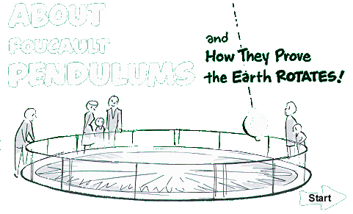

www.calacademy.org/products/pendulum
About Foucault Pendulums and how they prove the earths rotation - an animated, interactive web site created by the California Academy of Sciences to explain how pendulums work.



http://www.fossweb.com/modulesMS/index.html
You can link to the FOSS Resource database, which includes information about books, multimedia, software, and websites that extend the learning about forces and motion as well as other scientific areas.



http://www.tryscience.org/home.html
TryScience! is an interactive educational Web site that provides fun, engaging and stimulating learning material. The site has several activities encourage students to investigate and discover science. Students can do experiments, take virtual field trips to science museums, and participate in adventures.



http://monet.physik.unibas.ch/~elmer/pendulum/index.html
Welcome to the Pendulum Lab! In this is a virtual laboratory you can do hands-on experiments at rigid pendulum. Playing with the pendulum in the lab, you only need curiosity and a browser which can run Java applets.

