Question: What is a pendulum? What is the greatest amount of swings a pendulum can produce within a 15 second time period?

What’s Happening in Class? We have been exploring what makes pendulums special. Through inquiry, we worked in teams to determine what variable makes a pendulum produce the most swings. Ask me what I discovered? We have also learned that a pendulum with the same length, no matter the weight on the end, will take the same amount of time to swing. That's why they are great for telling time. Voila! That’s how the grandfather clock was born.

What Can We Do At Home?

- Discuss the following terms: pendulum, variable, motion, force, speed, direction.

- Set up your own pendulum investigation at home. Experiment with different variables.

- Investigate literature and internet resources to learn more about pendulums.

Check These Resources Out!
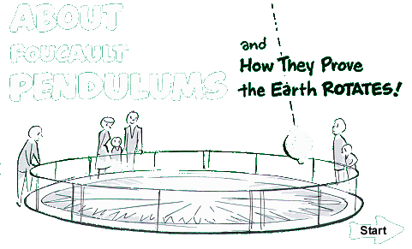
www.calacademy.org/products/pendulum
An animated, interactive web site created by the California Academy of Sciences to explain how pendulums work.


http://monet.physik.unibas.ch/~elmer/pendulum/index.html
Welcome to the Pendulum Lab! In this is a virtual laboratory you can do hands-on experiments on a pendulum.

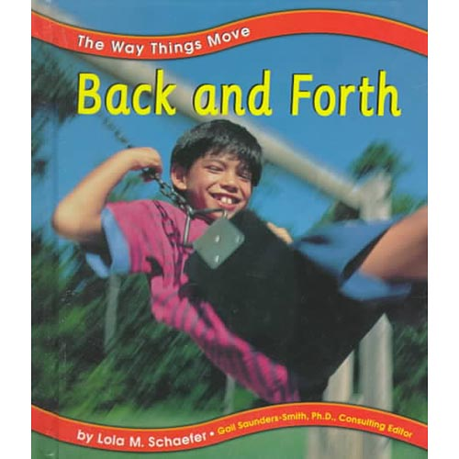
Back and Forth by Lola M. Schaefer Simple text and photographs provide examples of back and forth movement, including the pendulum on a clock, a child in a rocking chair, and a tree in the wind.

Challenge!!
1. Create a pendulum that would be used for a grandfather clock that swings exactly 60 times in1 minutes. Record the variables (height of the drop, mass of the bob, and length of the string) that you used. ____________________________________________________________________ ________________________________________________________________________________________________________________________________________

Some Pendulum Humor:

