Seeing Is Not Necessarily Believing picture file 3 of 3
Heather Blaylock
Lakota Plains Junior School
8th Grade Science
heather.blaylock@lakotaonline.com

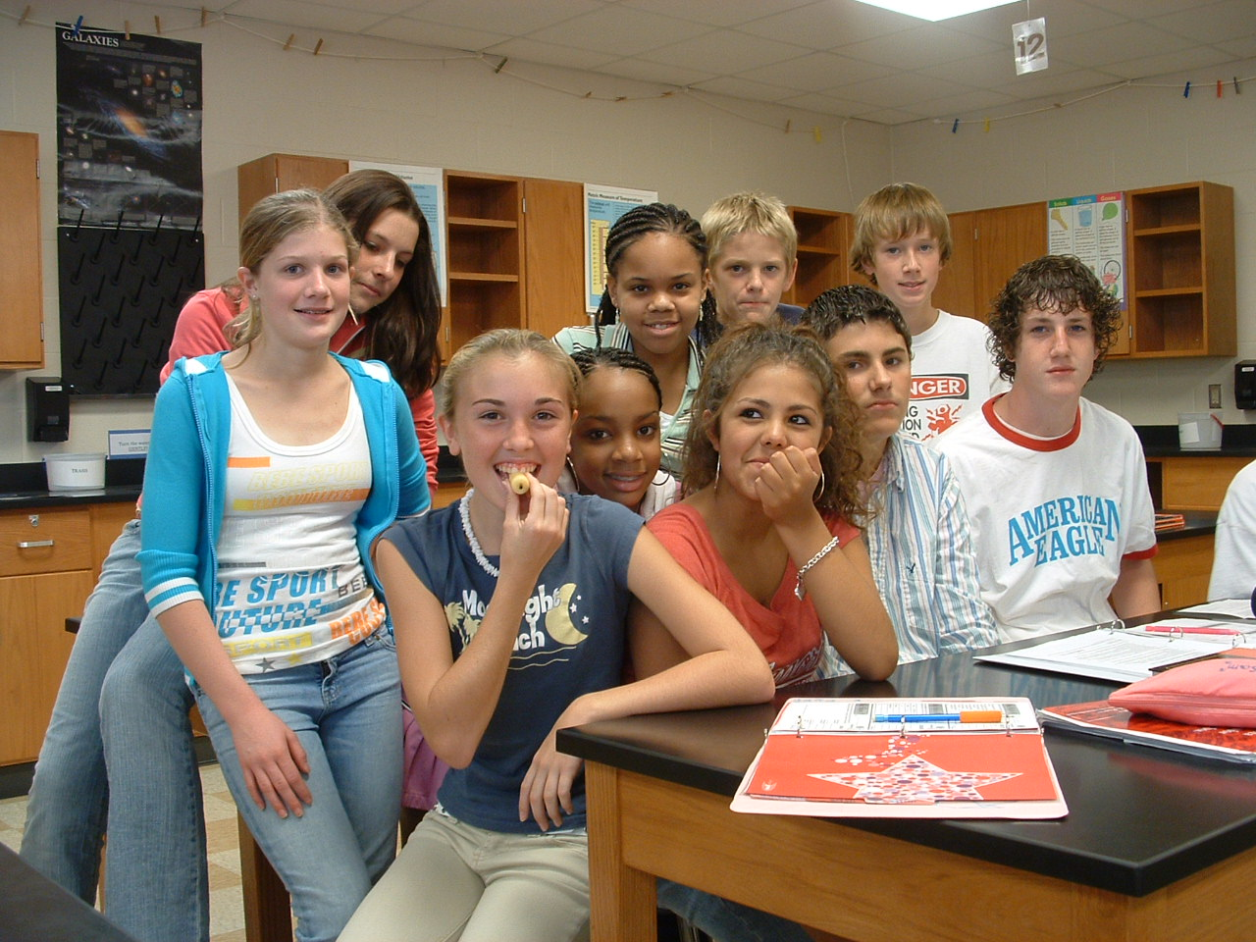

This picture shows one of my brave students, Fran, who volunteered to eat the candle so I could get a picture. The rest of the class, of course, wanted to be in the photo☺

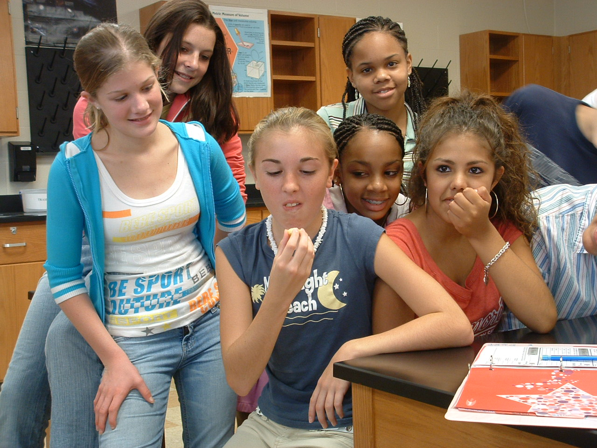

As you can see in this picture, Fran discovered that the burned nut wick doesn’t taste too good☺

