Seeing Is Not Necessarily Believing picture file 2 of 3
Heather Blaylock
Lakota Plains Junior School
8th Grade Science
heather.blaylock@lakotaonline.com

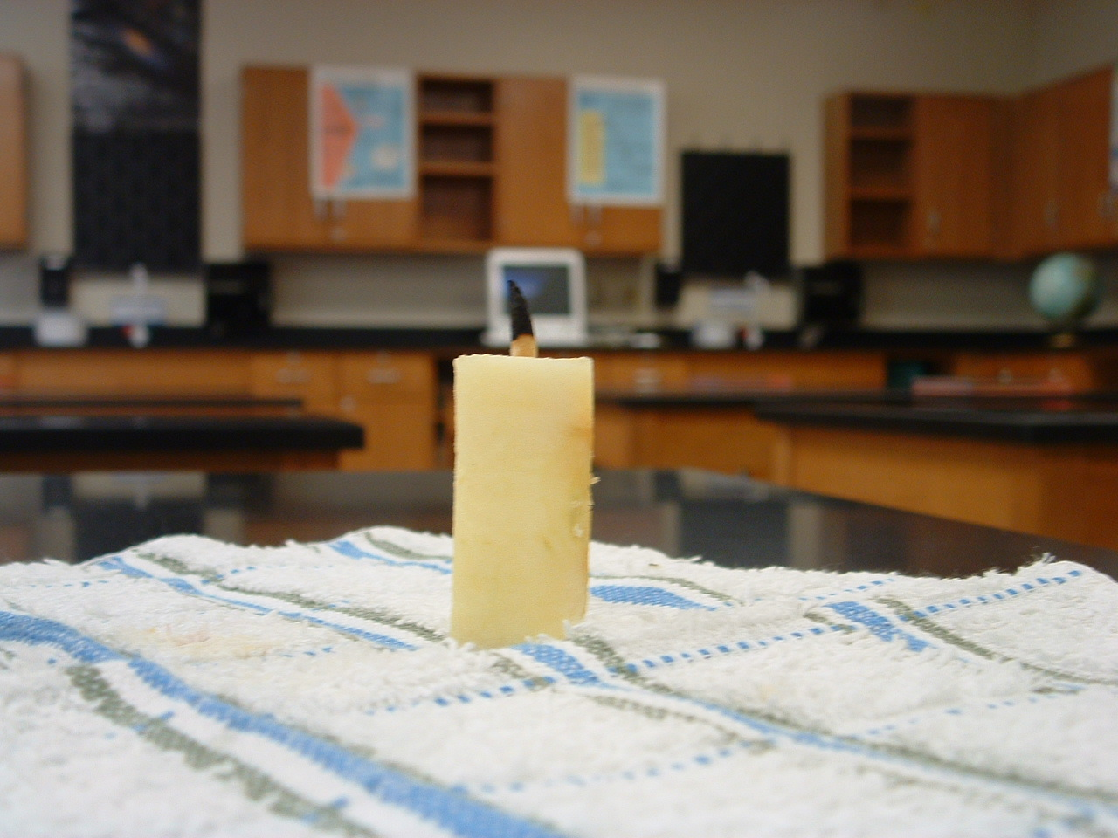

Here’s a picture of the candle after the wick has been burned.

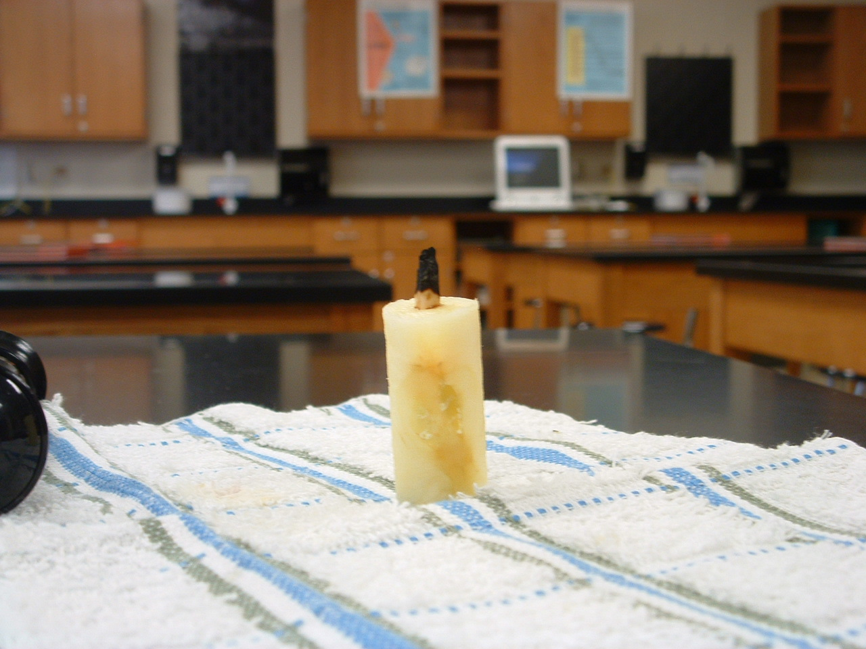

This picture shows the same candle from the other side. Part of the apple core is visible. To avoid this problem and still get a reasonably sized candle, use the largest apple you can find (wide rather than tall) to make the candle.

