Seeing Is Not Necessarily Believing picture file 1 of 3
written by Heather Blaylock
Lakota Plains Junior School
8th Grade Science
heather.blaylock@lakotaonline.com

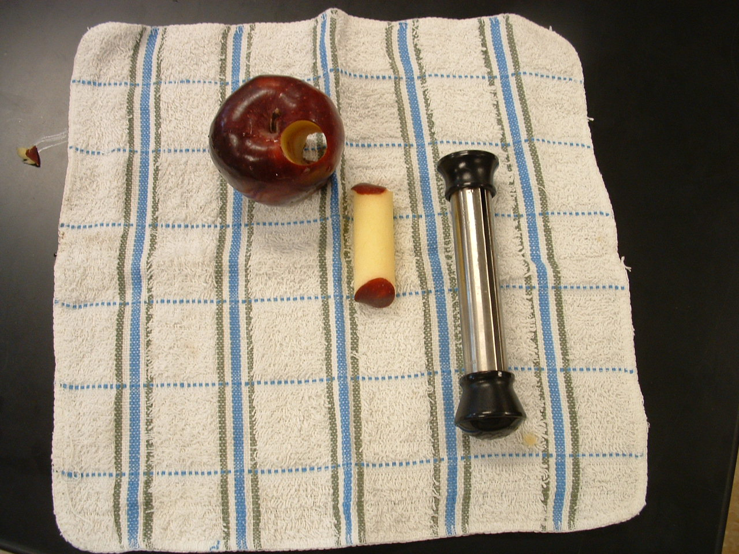

This picture shows the apple corer on the right, the cylinder section of apple taken out by the corer in the middle and the apple with the cylinder hole on the left.

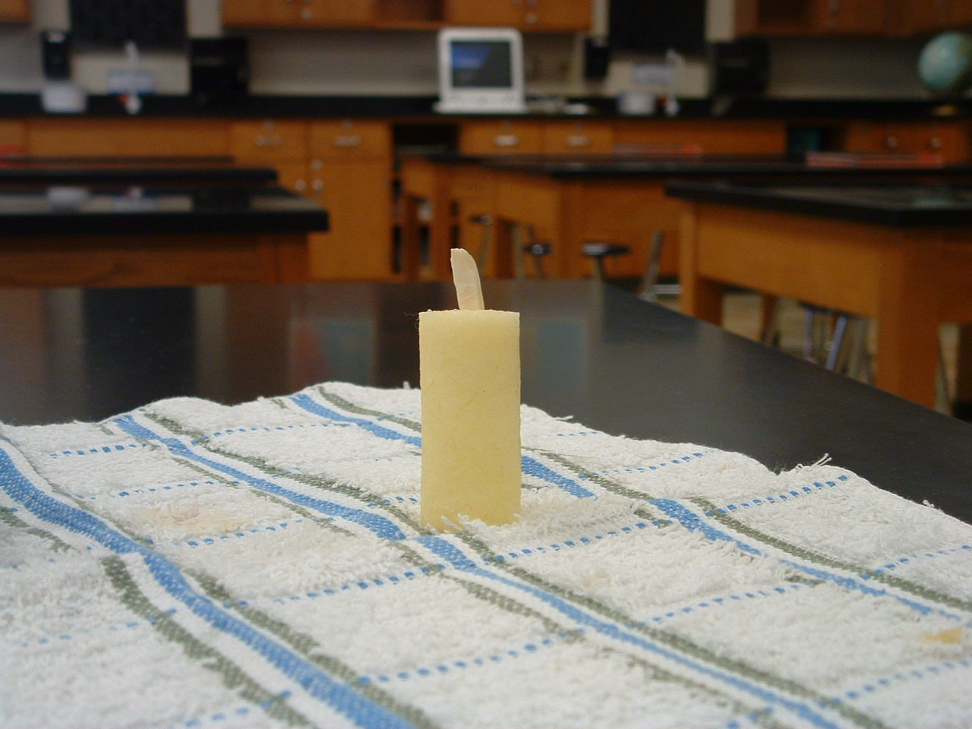

This picture shows the apple candle with the nut wick inserted in the top. To make the candle look more realistic, burn the nut wick just a little before showing it to your students.
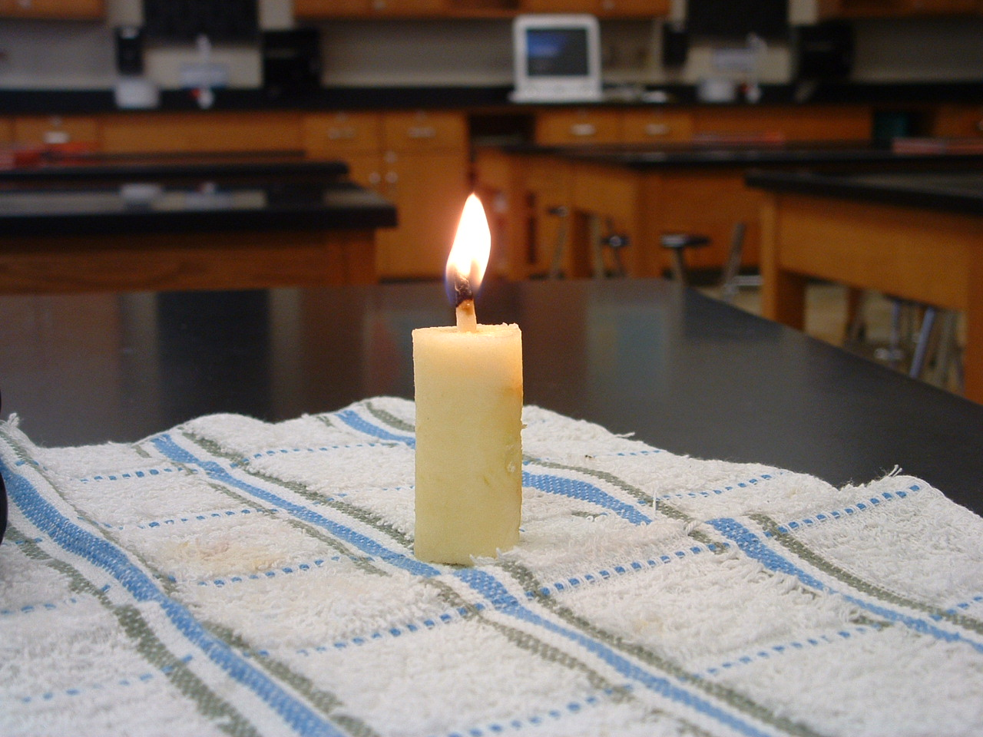

This picture shows the candle with the nut wick burning. It will burn for a short time and release a rather unpleasant odor to any sitting near.

